BSCS FINAL PROJECT
Software Requirements Specification

Desktop Automation using AI



Product Owner

Mam Saadia Aslam

Presented by:
Group ID: S26CS089

L1F22BSCS0124 Syed Muneeb
L1S23BSCS0144 Sania Amir
L1S23BSCS0152 Zoya Khalid

Faculty of Information Technology & Computer Science

Software Requirements Specification

Version: 1.0

Product Owner:

Mam Saadia Aslam

Scrum Master:

Sania Amir

Group ID:

S26CS089

Team
Member Name | Roles
Syed Muneeb Faraz | CV Screen Detection, Integration, Testing & Task Logging
Sania Amir | GUI, Voice Input, NLP, Automation Engine & Workflow Management
Zoya Khalid | GUI Interface, Voice Command Input & Speech-to-Text

Table of Contents
Table of Contents i
Revision History & Sprint Log ii
Previous Phases Feedback iii
Abstract 1
1. Introduction and Background 2
1.1 Product Vision & Problem Context 2
1.2 Stakeholders Identification 2
2. Agile Framework Setup 3
2.1 Epics For the Project 4
2.2 Product Backlog 5
2.3 User Stories 7
2.4 Story Points & Estimation 10
2.5 Sprint Planning & Sprint Backlog 11
3. Functional Requirements 13
3.1 Use Case Diagram 14
4. Non-functional Requirements 16
4.1 Reliability 16
4.2 Performance 17
4.3 Use-ability 17
4.4 Other Non-functional Requirements 18
5. Scrum Activities Plan 18
5.1 Kanban Board / Task Tracking 18
5.2 Acceptance Criteria 18
5.3 Release Criteria 19
5.4 Burndown Chart & Progress Tracking 20
5.5 Backlog Refinement Plan 22
6. Risk Analysis 23
7. References 25
Appendix A: Glossary 25
Appendix B: IV & V Report 27

Revision History & Sprint Log
Version | Sprint | Date | Changes | Owner
v0.1 | Sprint 1 | 2026-06-01 to 2026-06-14 | GUI interface and voice command input functionality; design GUI; add voice input functionality; test microphone integration | Sania Amir,  Zoya Khalid
v0.2 | Sprint 2 | 2026-06-18 to 2026-07-01 | Speech-to-text conversion and natural language processing; implement speech recognition; process natural language commands; test command interpretation accuracy | Sania Amir,  Zoya Khalid
v0.3 | Sprint 3 | 2026-06-18 to 2026-07-01 | Computer vision module for screen element detection; detect buttons and text fields; implement OCR and UI recognition; test screen detection across applications | Syed Muneeb Faraz
v0.4 | Sprint 4 | 2026-07-04 to 2026-07-17 | Automation engine and multi-step workflow execution; automate mouse and keyboard actions; execute workflows automatically; validate multi-step automation | Sania Amir,  Zoya Khalid
v0.5 | Sprint 5 | 2026-08-12 to 2026-08-25 | Workflow management and task logging features; save workflows in database; implement workflow editing/deletion; generate execution logs | Syed Muneeb Faraz,  Sania Amir,  Zoya Khalid
v1.0 | Sprint 6 | 2026-08-29 to 2026-09-11 | System integration, testing, debugging, and final improvements; integrate all modules; perform testing and debugging; optimize system performance; prepare final documentation | Syed Muneeb Faraz

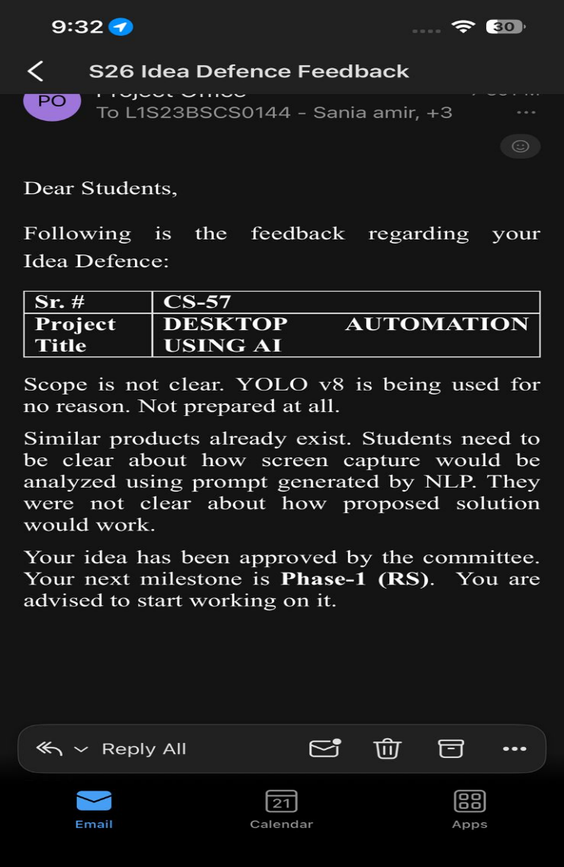

Previous Phases Feedback

Idea Defense Feedback (Screenshot)

Abstract
In the contemporary digital landscape, millions of students, freelancers, and corporate professionals expend significant cognitive effort and hours daily on repetitive, mundane desktop activities. These tasks, ranging from cross platform data entry and portal authentications to complex file management and form submissions, severely bottleneck human productivity [2]. While legacy Robotic Process Automation (RPA) tools exist, they present a steep learning curve requiring specialized scripting knowledge, or are bound by prohibitive enterprise licensing costs that alienate individual users and small-scale operations.
To bridge this gap, this project introduces a lightweight, intelligent, and highly accessible AI-powered desktop automation assistant [4]. The proposed system synthesizes advanced Natural Language Processing (NLP) with state-of-the-art Computer Vision (CV) to eliminate the need for traditional hardcoded scripts or coordinate-based execution. Through the NLP engine, the assistant parses and interprets unstructured, natural language user commands, converting intent into actionable system workflows [6]. Concurrently, the Computer Vision module dynamically scans the desktop environment, utilizing real-time screen element detection to identify user interface components such as buttons, text fields, and icons, regardless of screen resolution or application updates. By merging these two domains, the system delivers a robust, cross-platform automation engine capable of executing complex, multi-step workflows for non-technical users [10]. Ultimately, this solution democratizes desktop automation, drastically minimizing human operational errors, maximizing workflow efficiency, and reclaiming valuable hours for high-value tasks [2,3].

Introduction and Background

Product Vision & Problem Context
Problem Description: Users face frustration with monotonous digital tasks that consume up to 4.5 hours of their work week. Existing macro tools break easily when screen layouts change, and enterprise RPA tools like UiPath are too complex and costly for students and freelancers.

Target Users: Students, freelancers, and office workers.

Objectives:
- Develop a no-code AI desktop tool for automation [1].
- Decrease task execution time by at least 30% [5].
- Achieve an 80% accuracy rate in task execution across different apps.

Workflow Approach
The team will first gather and analyze requirements for the system. After requirement analysis, tasks will be added to the product backlog and divided into multiple sprints according to priority and complexity.

During each sprint:
- Tasks will be assigned to team members.
- Daily or regular progress discussions will be conducted.
- Completed features will be tested before moving to the next sprint.
- Feedback from the supervisor will be incorporated for continuous improvement.
This Agile workflow will help the team manage development efficiently, maintain proper coordination, and ensure timely completion of the project [7].

Stakeholders Identification

Product Owner (Mam Saadia Aslam): Expects a technically sound project that meets academic standards and effectively integrates AI
Primary Users (Students/Freelancers): Expect a simple, reliable tool to automate their daily digital chores.
Development Team: Responsible for building, testing, and documenting the system.

Relate stakeholders to real system users (e.g., student portal → students, admin staff).
Stakeholder | Real System User Relation | Expectations & Influence
Students (UCP) | User of Student Portals: Students who manually log in daily to check attendance, download slides, or upload assignments on the UCP portal. | Expects the AI to automate the login and navigation process to save time between classes.
Freelancers | User of Marketplaces & Editing Tools: Individuals using platforms like Fiverr/Upwork or software like Adobe Suite who perform repetitive file exports or data entry. | Expects a "no-code" experience where they can record a task once and let the AI repeat it accurately.
Admin Staff / Office Workers | User of Management Systems: Staff who handle repetitive form-filling, Excel data migration, or report generation in legacy desktop apps. | Expects high reliability and "Human-in-the-loop" logs to ensure no data is corrupted during automation.
Product Owner (Mam Saadia Aslam) | Academic Supervisor: The individual overseeing the project’s alignment with CS standards. | Expects the technical architecture (NLP and Computer Vision) to be robust and well-documented.
Development Team | System Architects: Syed Muneeb Faraz, Sania Amir, and Zoya Khalid. | Expects a modular codebase that allows for easy debugging of the automation engine.

Table 1.1: Analysis of target stakeholders, user portal relationships, and automation expectations.

Agile Framework Setup

Team Roles

Product Owner
The Product Owner of this project is Mam Sadia Aslam. The supervisor will guide the project requirements, monitor progress, review completed work, and provide feedback during sprint reviews.

Scrum Master
Zoya Khalid and Sania Amir will act as the Scrum Masters. The Scrum Master will manage sprint planning, task distribution, team coordination, and ensure smooth communication among all members.

Development Team
The development team consists of:
- Syed Muneeb Faraz: Computer Vision, Workflow Management System, System Integration and Testing
- Sania Amir: Frontend Development, NLP Integration, Automation Engine, Workflow Management System
- Zoya Khalid: NLP Integration, Frontend Development, Automation Engine, Logging and Reporting System

Sprint Duration
The project will follow a 2-week sprint cycle. At the beginning of each sprint, tasks and goals will be planned, and at the end of each sprint, completed work will be reviewed and evaluated.

Tools and Technologies for Agile Management
The following tools will be used during project development:
- Jira Task management and sprint tracking
- GitHub Version control and code management
- Google Meet / WhatsApp Team communication and meetings
- Python & PyQt5 Development technologies
- SQLite Database management

Epics for the Project
Epics represent the major functional modules of the proposed AI-powered desktop automation system. Each epic focuses on solving a specific problem area and contributes to the overall functionality of the system.

Epic ID | Epic Name | Description | Related Problem Area
EP-01 | User Interface Management | Handles the graphical user interface including command input, buttons, workflow display, and user interaction | Non-technical users face difficulty using complex automation tools
EP-02 | Natural Language Processing (NLP) Module | Processes and understands user commands written in natural language | Existing tools require coding or technical workflow creation
EP-03 | Computer Vision Detection | Detects screen elements such as buttons, icons, text fields, and menus using computer vision | Traditional automation tools fail when UI layouts change
EP-04 | Automation Engine | Executes automated actions such as mouse clicks, typing, scrolling, opening applications, and workflow execution | Users spend excessive time performing repetitive manual tasks
EP-05 | Workflow Management System | Stores, manages, and reuses user workflows for repeated automation tasks | Users repeatedly perform the same workflows manually
EP-06 | Logging and Reporting System | Maintains logs of executed tasks and generates activity reports for monitoring and evaluation | Users cannot track completed automated operations effectively
EP-07 | System Integration & Testing | Integrates all modules and performs testing to ensure smooth system functionality | Integration issues may reduce system reliability and performance

Table 2.1: Architectural epics breakdown with description and targeted automation bottlenecks.

Product Backlog

The product backlog contains all major features and functionalities required for the successful development of the AI-powered desktop automation system. The backlog items are prioritized according to their importance and implementation needs.

Backlog ID | Epic | Feature Description | Priority
PB-01 | User Interface Management | Design the main desktop graphical user interface (GUI) | High
PB-02 | User Interface Management | Create voice command input interface using microphone integration | High
PB-03 | User Interface Management | Add buttons for task execution and workflow control | Medium
PB-04 | Natural Language Processing Module | Implement natural language command recognition | High
PB-05 | Natural Language Processing Module | Process commands such as “Open Chrome” or “Fill Form” | High
PB-06 | Natural Language Processing Module | Improve command interpretation accuracy | Medium
PB-07 | Computer Vision Detection | Detect buttons, icons, and text fields on screen | High
PB-08 | Computer Vision Detection | Implement OCR for reading on-screen text | Medium
PB-09 | Computer Vision Detection | Detect UI elements across different applications | High
PB-10 | Automation Engine | Automate mouse clicks and keyboard typing | High
PB-11 | Automation Engine | Open and control desktop applications automatically | High
PB-12 | Automation Engine | Execute multi-step workflows automatically | High
PB-13 | Workflow Management System | Save user-created workflows for reuse | Medium
PB-14 | Workflow Management System | Allow editing and deleting saved workflows | Medium
PB-15 | Logging and Reporting System | Generate logs of executed automation tasks | Medium
PB-16 | Logging and Reporting System | Display workflow execution history | Low
PB-17 | System Integration & Testing | Integrate NLP, CV, and automation modules | High
PB-18 | System Integration & Testing | Perform testing and debugging of workflows | High

Table 2.2

User Stories
Story ID | Backlog ID | User Story | Priority | Acceptance Criteria | Focal Person Responsible
US-01 | PB-01 | As a user, I want a simple graphical interface so that I can interact with the system easily | High | GUI loads successfully and all interface components are visible | Sania Amir
US-02 | PB-02 | As a user, I want to give voice commands so that I can automate tasks without typing | High | System successfully records user voice input | Zoya Khalid
US-03 | PB-04 | As a user, I want the system to convert speech into text so that my commands can be processed automatically | High | Spoken commands are converted into text correctly | Sania Amir
US-04 | PB-05 | As a user, I want the system to understand natural language voice commands so that I can automate tasks easily | High | Voice commands are interpreted correctly by the system | Zoya Khalid
US-05 | PB-07 | As a user, I want the system to detect buttons and text fields on screen so that tasks can be performed automatically | High | UI elements are detected correctly on screen | Syed Muneeb Faraz
US-06 | PB-10 | As a user, I want the system to perform mouse clicks and keyboard typing automatically so that repetitive tasks are reduced | High | Mouse and keyboard automation execute successfully | Sania Amir
US-07 | PB-12 | As a user, I want multi-step workflows automated so that repetitive processes are completed faster | High | Multiple automation steps execute successfully in sequence | Zoya Khalid
US-08 | PB-13 | As a user, I want to save workflows so that I can reuse them later | Medium | Workflow is stored successfully in the system | Syed Muneeb Faraz
US-09 | PB-14 | As a user, I want to edit or delete workflows so that I can manage automation tasks easily | Medium | Workflow updates and deletions work correctly | Sania Amir
US-10 | PB-15 | As a user, I want task execution logs so that I can monitor completed automation tasks | Medium | Logs are displayed correctly after execution | Zoya Khalid
US-11 | PB-18 | As a user, I want the system tested properly so that automation tasks run reliably without errors | High | System performs workflows successfully during testing | Syed Muneeb Faraz

Table 2.3

Story Points & Estimation
Story ID | User Story (Short) | Complexity Level | Story Points | Justification
US-01 | GUI Interface | Medium | 3 | Requires GUI design and user interaction components
US-02 | Voice Command Input | Medium | 3 | Requires microphone integration and voice recording functionality
US-03 | Speech to Text Conversion | High | 5 | Requires speech recognition processing and accuracy handling
US-04 | Natural Language Understanding | High | 8 | Involves NLP processing and command interpretation
US-05 | UI Element Detection | High | 8 | Requires computer vision and screen analysis
US-06 | Automation Execution | High | 8 | Requires mouse, keyboard, and workflow automation logic
US-07 | Multi-Step Workflow Automation | High | 8 | Multiple dependent automation tasks must execute sequentially
US-08 | Workflow Saving | Medium | 8 | Requires workflow storage and retrieval using database
US-09 | Workflow Editing & Deletion | Medium | 5 | Requires workflow management operations
US-10 | Task Logging System | Medium | 3 | Requires logging and display of execution history
US-11 | System Testing | Medium | 3 | Requires integration testing and debugging of all modules

Table 2.4

Sprint Planning & Sprint Backlog
Sprint No. | Duration | Selected User Stories | Sprint Goal | Total Story Points
Sprint 1 | 2 Weeks | US-01, US-02 | Develop GUI interface and voice command input functionality | 6
Sprint 2 | 2 Weeks | US-03, US-04 | Implement speech-to-text conversion and natural language processing | 13
Sprint 3 | 2 Weeks | US-05 | Develop computer vision module for screen element detection | 8
Sprint 4 | 2 Weeks | US-06, US-07 | Implement automation engine and multi-step workflow execution | 16
Sprint 5 | 2 Weeks | US-08, US-09, US-10 | Develop workflow management and task logging features | 16
Sprint 6 | 2 Weeks | US-11 | Perform system integration, testing, debugging, and final improvements | 3

Table 2.5

Sprint Backlog Overview

Sprint 1
- Design GUI
- Add voice input functionality
- Test microphone integration

Sprint 2
- Implement speech recognition
- Process natural language commands
- Test command interpretation accuracy

Sprint 3
- Detect buttons and text fields
- Implement OCR and UI recognition
- Test screen detection across applications

Sprint 4
- Automate mouse and keyboard actions
- Execute workflows automatically
- Validate multi-step automation

Sprint 5
- Save workflows in database
- Implement workflow editing/deletion
- Generate execution logs

Sprint 6
- Integrate all modules
- Perform testing and debugging
- Optimize system performance
- Prepare final documentation

Functional Requirements

Use Case Diagram

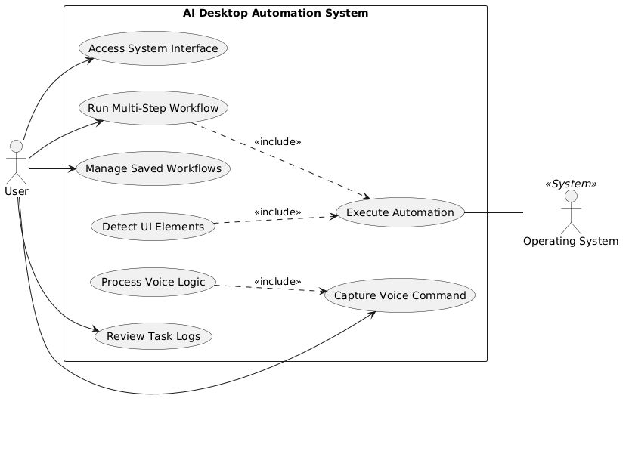

Use Case ID | Use Case Name | Primary Actor | Description | Mapped User Story ID | User Story
UC-01 | Access System Interface | User | Provides a graphical window for the user to interact with all system features. | US-01 | As a user, I want a simple graphical interface so that I can interact with the system easily
UC-02 | Capture Voice Command | User | Activates the microphone and records spoken instructions from the user. | US-02 | As a user, I want to give voice commands so that I can automate tasks without typing
UC-03 | Process Voice Logic | System | Converts speech-to-text and interprets the intent of the command using NLP. | US-03, US-04 | As a user, I want the system to understand natural language voice commands so that I can automate tasks easily
UC-04 | Detect UI Elements | System | Uses computer vision to scan the screen and identify the location of buttons or icons. | US-05 | As a user, I want the system to detect buttons and text fields on screen so that tasks can be performed automatically
UC-05 | Execute Automation | System | Performs physical mouse movements, clicks, and keyboard inputs on the desktop. | US-06 | As a user, I want the system to perform mouse clicks and keyboard typing automatically so that repetitive tasks are reduced
UC-06 | Run Multi-Step Workflow | User / System | Coordinates a sequence of automation steps to complete a complex task. | US-07 | As a user, I want multi-step workflows automated so that repetitive processes are completed faster
UC-07 | Manage Saved Workflows | User | Allows the user to store, edit, or delete previously recorded automation sequences. | US-08, US-09 | As a user, I want to save, edit or delete workflows so that I can manage automation tasks easily
UC-08 | Review Task Logs | User | Displays a history of all automated actions and their success/failure status. | US-10 | As a user, I want task execution logs so that I can monitor completed automation tasks

Table 3.1

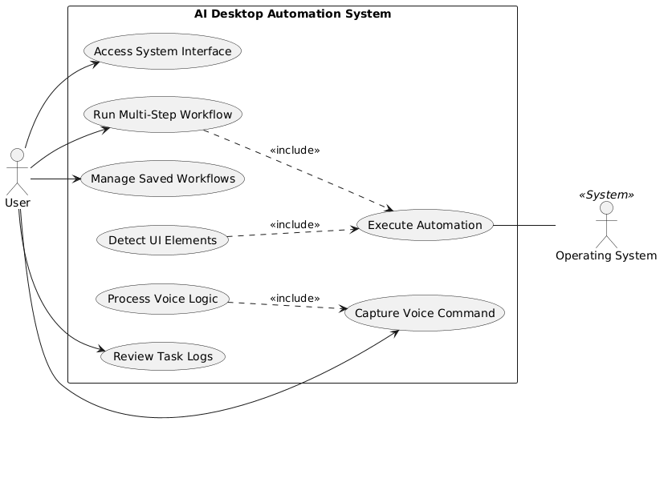

Non-functional Requirements

Reliability
Requirement ID | Requirement Description
NFR-01 | The system shall execute automation tasks with at least 80% accuracy.
NFR-02 | The system shall continue functioning without major crashes during normal usage.
NFR-03 | The system shall handle invalid or unclear voice commands gracefully by displaying an error message.
NFR-04 | The system shall maintain workflow logs for monitoring executed tasks.

Table 4.1

Performance
Requirement ID | Requirement Description
NFR-05 | The system shall begin processing voice commands within 2–3 seconds.
NFR-06 | The system shall execute automation workflows without significant delays.
NFR-07 | The system shall support smooth interaction while running multiple automation tasks.
NFR-08 | The system shall detect screen elements efficiently during workflow execution.

Table 4.2

Usability
Requirement ID | Requirement Description
NFR-09 | The system shall provide a simple and user-friendly graphical interface.
NFR-10 | The system shall allow non-technical users to automate tasks without programming knowledge.
NFR-11 | The system shall provide clear buttons, labels, and workflow options for easy navigation.
NFR-12 | The system shall support voice-based interaction for easier task execution.

Table 4.3

Other Non-functional Requirements
Requirement ID | Requirement Description
NFR-13 | The system shall store workflows and logs locally using SQLite database.
NFR-14 | The system shall support automation across multiple desktop applications.
NFR-15 | The system shall protect stored workflow data from unauthorized modification.
NFR-16 | The system shall allow future scalability for adding new automation features and AI capabilities.

Table 4.4

Scrum Activities Plan

Daily Scrum Plan
The team will conduct short daily or regular Scrum meetings through WhatsApp or Google Meet. Each meeting will last approximately 10–15 minutes.
During the Daily Scrum:
- Team members will discuss completed tasks.
- Current development progress will be reviewed.
- Any technical issues or blockers will be identified.
- Upcoming tasks for the day will be planned.
This process will help maintain communication and ensure that all members remain aligned with sprint goals.

Sprint Review Process
At the end of every sprint, a Sprint Review meeting will be conducted with the supervisor and team members.
During the Sprint Review:
- Completed features and modules will be demonstrated.
- Progress against sprint goals will be evaluated.
- Feedback from the supervisor will be collected.
- Necessary improvements or modifications will be identified.
This review process will help ensure that the project is progressing according to requirements and expectations.

Sprint Retrospective Plan

After each Sprint Review, the team will conduct a Sprint Retrospective session to evaluate overall team performance and workflow efficiency.
During the Sprint Retrospective:
- Team members will discuss challenges faced during development.
- Successful practices will be identified.
- Suggestions for improving communication, task management, and development workflow will be discussed.
- Plans for improving the next sprint will be prepared.
The retrospective process will help the team continuously improve project development practices and collaboration throughout the project lifecycle.

Kanban Board / Task Tracking
To Do | In Progress | Testing | Done
Design workflow saving module | Implement speech recognition | Test voice command accuracy | Setup project structure
Create task logging interface | Develop NLP command processing | Validate UI element detection | Requirement analysis completed
Add workflow editing feature | Implement automation engine | Test workflow execution | GUI prototype completed
Develop reporting module | Integrate computer vision module | Perform integration testing | Database schema created
Improve user interface | Implement workflow management | Debug automation errors | Literature review completed

Table 5.1

Acceptance Criteria
Feature / Requirement | Test Scenario | Expected Result
Voice Command Input | User gives a voice command through microphone | System successfully records the voice input
Speech to Text Conversion | User speaks a command such as “Open Chrome” | System correctly converts speech into text
Natural Language Processing | User gives different automation commands | System correctly interprets the intended action
Screen Element Detection | System scans desktop screen for buttons and text fields | Required UI elements are detected successfully
Automation Execution | User requests an automation task | System performs clicks, typing, and navigation automatically
Multi-Step Workflow Automation | User executes a saved workflow | Multiple automation steps execute in correct sequence
Workflow Saving | User saves a workflow | Workflow is stored successfully in the database
Workflow Management | User edits or deletes an existing workflow | Workflow updates or deletion complete successfully
Task Logging System | User executes automation tasks | System stores and displays execution logs correctly
System Integration | All modules are executed together | System performs automation without major crashes or failures
Performance Requirement | User gives a voice command | Command processing begins within 2–3 seconds
Usability Requirement | Non-technical user interacts with system | User can operate the system without coding knowledge

Table 5.2

Release Criteria
Release Criteria ID | Release Condition / Approval Requirement
RC-01 | All planned modules and core features are implemented successfully
RC-02 | Voice command input and speech-to-text conversion function correctly
RC-03 | Natural language commands are interpreted accurately by the system
RC-04 | Computer vision module successfully detects screen elements

RC-05 | Automation workflows execute without major failures or crashes
RC-06 | Workflow saving, editing, and deletion features operate correctly
RC-07 | Task logs and reporting functionalities are generated successfully
RC-08 | System testing and debugging are completed successfully
RC-09 | The system achieves acceptable performance and reliability during evaluation
RC-10 | Supervisor approval is obtained after successful demonstration of the project

Table 5.3

Burndown Chart & Progress Tracking
Project progress will be monitored using sprint-based tracking and a burndown chart approach. The team will track completed and remaining work throughout each sprint to ensure timely completion of project tasks and objectives.

Work Tracking Method
The development team will use:
- Jira for task management, product backlog organization, and sprint tracking.
- Scrum Boards inside Jira to monitor task progress across workflow states (To Do, In Progress, Done).
- Weekly progress reviews with the supervisor.
- Sprint completion reports and automated Jira velocity charts to evaluate completed work.
Each task and user story will be assigned story points based on complexity and effort. As tasks are completed, the remaining story points will decrease, showing overall project progress.

Burndown Chart Concept
A burndown chart is a graphical representation used in Agile Scrum to compare:
- Remaining work (measured in Story Points)
- Time remaining in the sprint lifecycle
The chart helps the team monitor whether development is progressing according to schedule.

Expected Burn Rate
The expected burn rate refers to the amount of work completed during each sprint. The team aims to complete the assigned story points within the planned sprint duration.
Expected sprint progress:
- Sprint 1: GUI layout design and user voice input interface configuration.
- Sprint 2: Core speech recognition logic and local NLP command interpretation.
- Sprint 3: Computer vision element detection and screen coordinate mapping.
- Sprint 4: Automation execution engine backend logic and mouse/keyboard simulation loops.
- Sprint 5: Relational SQLite workflow storage implementation and transaction logging systems.
- Sprint 6: End-to-end integration, automated debugging passes, and final system evaluation.
The burndown tracking process will help identify delays early, improve workload management, and ensure smooth project development throughout the project lifecycle.

Backlog Refinement Plan
The product backlog will be reviewed and updated regularly throughout the project development process to ensure that tasks, priorities, and requirements remain aligned with project goals and supervisor feedback.

Backlog Refinement Frequency
Backlog refinement activities will be conducted:
- At the end of each active sprint cycle.
- During routine sprint planning sessions.
- Whenever new technical dependencies, requirements, or system defects are identified.
Regular refinement will help the team manage tasks effectively and maintain accurate sprint planning.

Backlog Refinement Process
During backlog refinement:
- Existing backlog items will be reviewed, estimated, and updated within Jira.
- Completed tasks will be formally closed out from the active product backlog.
- New system features, architecture updates, or bug fixes will be added to the backlog queue.
- Task priorities will be adjusted dynamically according to project dependencies and supervisor feedback.
- Complex engineering tasks will be progressively decomposed into smaller, modular, and manageable user stories.
The development team will collaboratively discuss individual workloads, code dependencies, and backend implementation challenges before finalizing backlog updates.

Continuous Improvement Approach
The team will follow a continuous improvement approach by regularly analyzing sprint outcomes, system validation results, and feedback received during supervisor reviews. This process will help optimize team task management, velocity, workflow efficiency, and overall project engineering quality throughout the development lifecycle.

Risk Analysis

Risk ID | Risk Description | Impact on Project | Mitigation Strategy
R-01 | Speech recognition may fail to accurately understand user voice commands | Incorrect command processing and automation errors | Use testing with different voice samples and improve command handling logic
R-02 | Computer vision may fail to detect UI elements correctly when application layouts change | Automation workflows may not execute properly | Implement flexible screen detection and test across multiple applications
R-03 | Integration issues may occur between NLP, computer vision, and automation modules | System instability and delays in development | Perform module integration gradually with continuous testing
R-04 | Automation tasks may execute slowly on low-performance systems | Reduced system performance and poor user experience | Optimize workflows and reduce unnecessary background processing
R-05 | Team members may face communication or coordination issues | Delays in sprint completion and task management | Conduct regular meetings and maintain communication through Trello and WhatsApp
R-06 | Limited project development time may affect completion of advanced features | Some features may remain incomplete before final submission | Prioritize core functionalities and manage sprint workload effectively
R-07 | Bugs or unexpected errors may occur during workflow automation | System crashes or incorrect automation execution | Perform regular debugging, testing, and validation during each sprint
R-08 | Dependency on third-party Python libraries may create compatibility issues | Some modules may not function properly after updates | Use stable library versions and maintain backup alternatives
R-09 | Voice input may be affected by background noise or unclear pronunciation | Reduced speech recognition accuracy | Use noise filtering and test the system in different environments
R-10 | Data loss or workflow corruption may occur due to system failure | Loss of saved workflows and logs | Store workflow data securely in SQLite database with regular backups

Table 6.1

References
[1] UiPath, 2019
[2] Kryon Systems, 2021
[3] Willcocks et al., 2017
[4] [4] Lasecki, W. S., et al. (2012). "Intelligent user interfaces for non-technical users." ACM Transactions on Computer-Human Interaction, 19(3).
[5] [5] Avasarala, V., et al. (2019). "RPA tools: Challenges and opportunities." Journal of Robotics and Automation, 14(1), 50-65.
[6] [6] Kumar, S., et al. (2020). "Natural language processing for intelligent automation systems." AI in Automation Review, 25(2), 99-112.
[7] [7] Sarma, A. K., & Narayana, M. (2017). "Automating repetitive tasks in the office environment." Computers in the Office Environment, 30(4), 102-115.
[8] [8] Brady, M., et al. (2018). "Time and task management in professional settings." Journal of Office Productivity, 45(2), 50-60.
[9] [9] Brown, J., & Wilson, T. (2016). "Addressing the errors in manual workflows." Human-Computer Interaction Journal, 34(1), 18-29.
[10] [10] Sutherland, W., et al. (2018). "Robotic Process Automation: A business transformation tool." Journal of Business Innovation, 40(1), 1-10.
[11] [11] Reddy, P., et al. (2020). "Leveraging AI for desktop automation: The future of personal assistants." AI Systems and Tools Journal, 15(3), 77-90.

Appendix A: Glossary
Term / Acronym | Definition
AI | Artificial Intelligence
NLP | Natural Language Processing
GUI | Graphical User Interface.
OCR | Optical Character Recognition
CV | Computer Vision
RPA | Robotic Process Automation
SRS | Software Requirements Specification
Sprint | A short development cycle in Agile Scrum methodology used to complete specific tasks.
Scrum | An Agile project management framework used for iterative software development.
Product Backlog | A prioritized list of project features, tasks, and requirements.
User Story | A short description of a system feature written from the user’s perspective.
Story Points | Estimation units used to measure task complexity and development effort.
Scrum Board | A digital, sprint-based visual tracking board inside Jira used to monitor active task progress, manage team velocity, and view work transitions across defined states (To Do, In Progress, and Done).
Burndown Chart | A chart used in Agile to track remaining work during project development.
SQLite | A lightweight relational database used for storing workflows and logs.
PyQt5 | A Python framework used for designing graphical desktop applications.
Speech Recognition | Technology that converts spoken voice commands into text.
Workflow | A sequence of automated actions performed by the system.
Automation Engine | Core module responsible for executing automated desktop actions.
UI Elements | Visual components such as buttons, icons, menus, and text fields present on screen.

Appendix B: IV & V Report
(Independent verification & validation)
IV & V Resource

Name Signature
Syed Muneeb Faraz
Sania Amir
Zoya Khalid

S# | Defect Description | Origin Stage | Status | Fix Time
Table 3: List of non-trivial defects

